Smart wiper control system

Abstract:

Wiper is an essential component that used to wipe raindrops or any water from the vehicle’s windscreen. The previous system used to activate the wiper manually and the process of pulling up the wiper is difficult to be handled. Thus, this system is proposed to solve these problems. The objectives of this project are to upgrade the older cars system by providing automatic wiping system, to improve the system by using sensor with actuator and to design a basic program that will fully operate with the system. The concept of this proposed wiper system is similar with other existing conventional wiper. In spite of removing water from windscreen, this system also will be upgraded to an automatic control system by using a Peripheral Interface Controller (PIC) 16F877A controller and water sensor. As the conclusion for the project, the results shows all the aim objectives are successfully achieved. The wiper system was well functionally according the water condition from the outside of a car. This project showed a contribution on the design of the automatic wiper system for the future research in this same field. It is recommended that the system to have a study on the wiper material that been used to make a wiper because the driver at hot and climate country are facing the problems regards to the wiper material.

Keywords: Actuator, PIC16F877 Microcontroller, Sensor Plate, Water Sensor, Wiper.

**1.INTRODUCTION**

Wiper is an essential component that used to wipe the raindrops or any water from the windscreen. Wipers are designed and made to clear the water from windscreen. Most of cars have two wipers on the windscreen, one on the rear window and the other on each headlight. The wiper parts visible from outside the car are the rubber blade, the wiper arm holding the blade, a spring linkage, and parts of the wiper pivots. The wiper itself has about six parts called pressure points or claws that are small arms under the wiper.

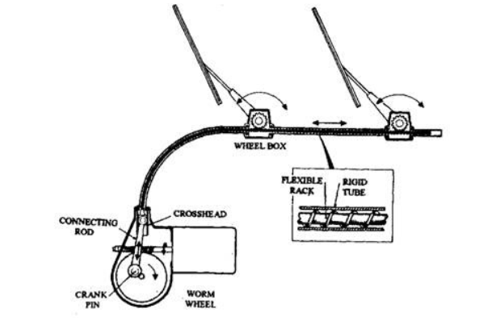

Existing system manually used control stalk to activate wiper and the process of pulling up wiper is difficult to be handled. The driver needs to switch on and off the control stalk and it will reduce the driver’s concentration during the driving. Thus, this system is proposed to solve all these problems. The concept of this wiper system is similar with other conventional wiper, yet this system will be upgraded to an automatic control system by using a controller. Whenever the water hit a dedicated sensor that located on windscreen, it will send a signal to move on the wiper motor. Once water is not detected by sensor, the wiper will automatically stop. This will help the driver to give more concentration and reduce the car accident probability. In this project, there were two innovations reviewed as the literature review. The two were designed with different concept and operating mechanism however with same objective of working principle of the car wiper. The rain sensor was a highly versatile device for automatic wiping of vehicle windscreen when it is wet due to moisture, raindrops or even mud . It worked by reflecting harmonious light beams within the windscreen. When raindrops fall onto the windscreen, this harmony light is been disturbed and creating a drop in the light beam intensity. The system then activated the wipers to be operated in full automatic mode. It has a response time at 0.1 seconds. It allowed for a quick reaction when it is a sudden splashes of water that will make the driver totally ‘blinds’ when the situation happened. With the automatic wiper, the driver can avert from the risk of an accident. The automatic wiper is important during the heavy traffic e.g. in town, city, school zone and other public place. A driver may be subjected to many distractions with bad weather, dangerous road conditions and fatigue. The Rain Sensor reduced the driver’s burden by making the driving more comfortable. Trailing a wet car is no longer a nuisance as detection of even 0.005 milliliters of water is possible.

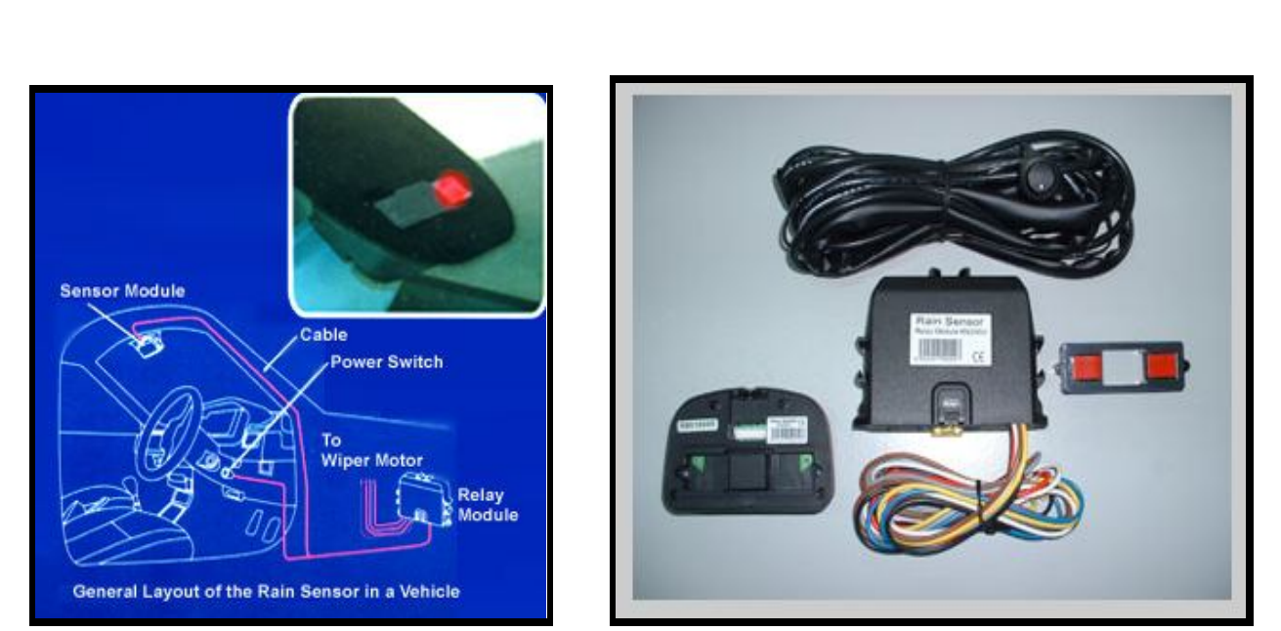

Ram sensor wiper system

The Z8 BIAC 010 by Albert Ziegler controlled wiper automatically by the Rain Tracker Windshield Wiper Control System. It operated in parallel with the existing wiper system. The Rain Tracker will sense rain, snow or road spray hitting the windshield, and it will automatically run the wipers at the right speed. By using Rain Tracker, it will ease the car driver to turn on and off the wiper, so that the users do not have to take hands off the wheel or other control to adjust the wipers as road conditions change. It senses all kind of precipitation such as rain, mist, snow or sleet and can operate in full range from off through intermittent, slow and fast speeds [3]. The Rain Tracker uses beams of infrared light to sense how much water hits the windscreen. It constantly adjusts the speed of the wipers so that they run just often enough to keep the windshield clear from all the way off to the high speed.

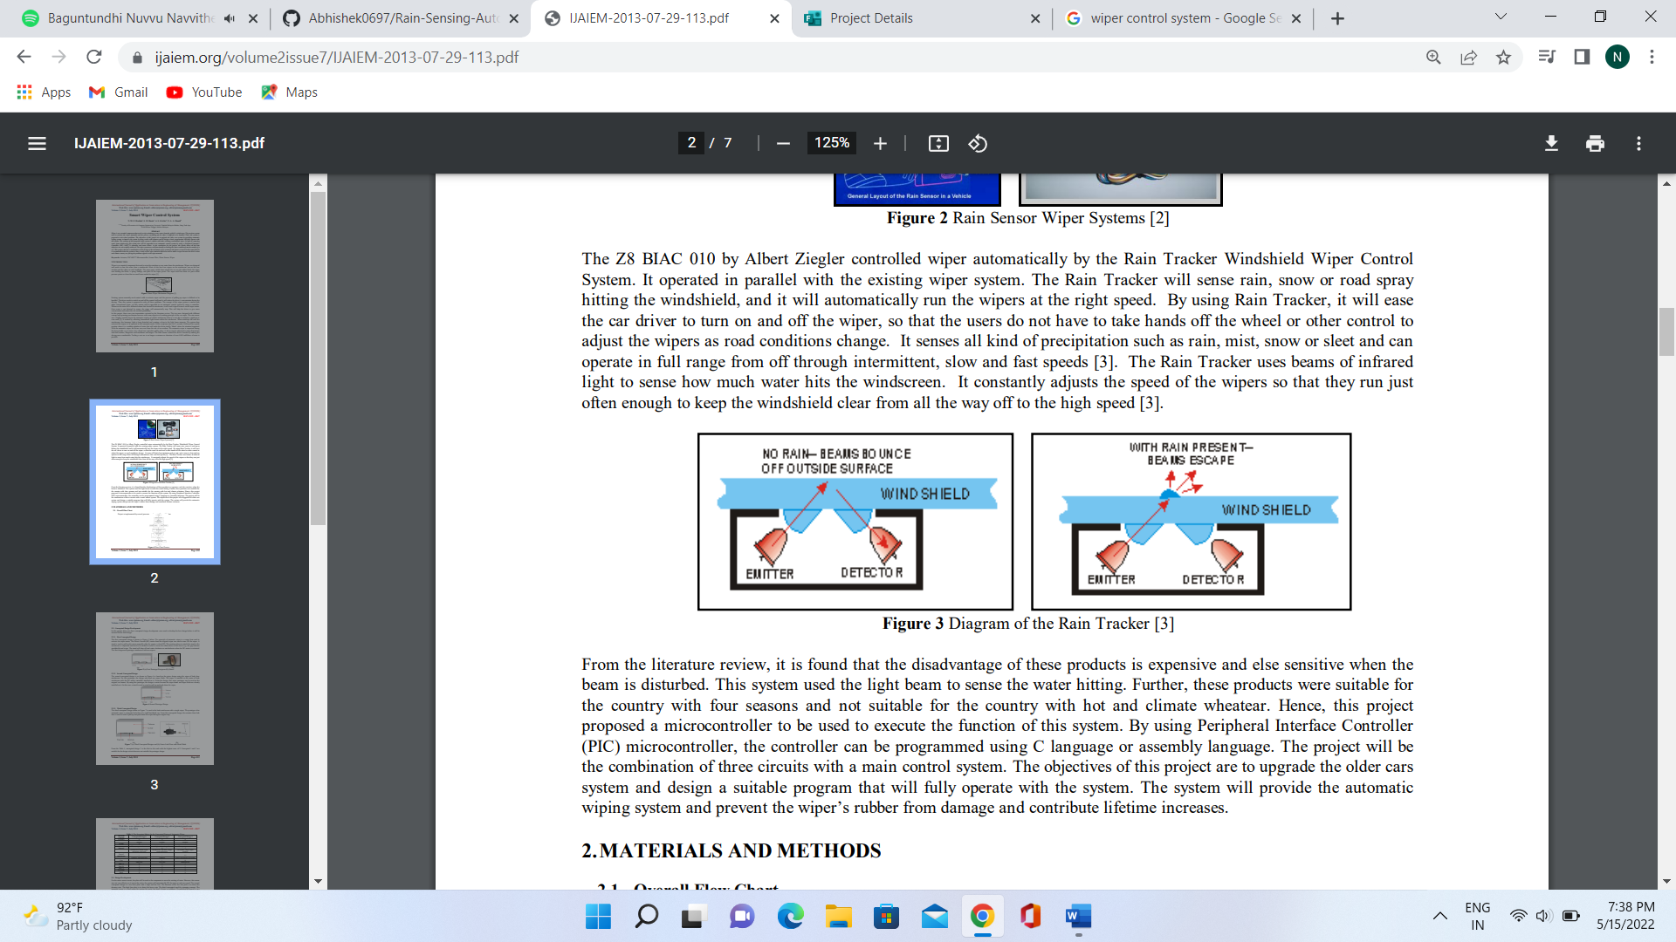

From the literature review, it is found that the disadvantage of these products is expensive and else sensitive when the beam is disturbed. This system used the light beam to sense the water hitting. Further, these products were suitable for the country with four seasons and not suitable for the country with hot and climate wheatear. Hence, this project proposed a microcontroller to be used to execute the function of this system. By using Peripheral Interface Controller (PIC) microcontroller, the controller can be programmed using C language or assembly language. The project will be the combination of three circuits with a main control system. The objectives of this project are to upgrade the older cars system and design a suitable program that will fully operate with the system. The system will provide the automatic wiping system and prevent the wiper’s rubber from damage and contribute lifetime increases.

**Overall Flow Chart**

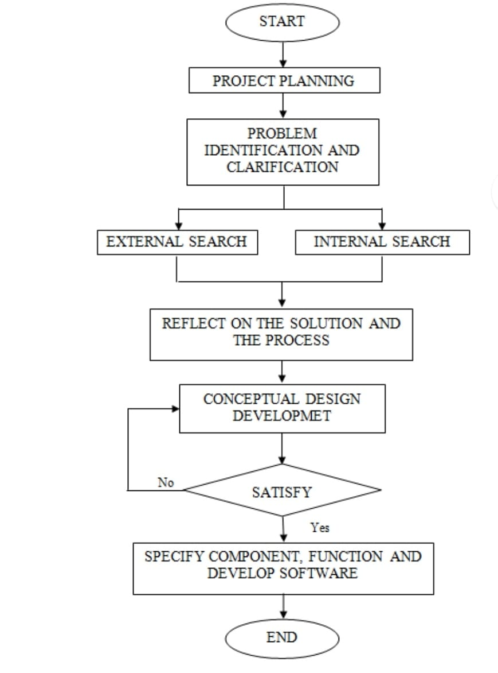

**Design Development**

For the water sensor circuit, the plate will be used as the component to sense the existing of water. However, this sensor was not very effective as it senses the water, the system will automatically ON the wiper at only one speed. The second conceptual design is a two lines plate with a high and low line. The function of the low line plate is to detect the showery rain. The high line plate is to detect the heavy rain. The third conceptual used the stamping concept. The stamping sensor is a good sensor for sensing the moist, any kind of water or raindrops. Nevertheless the sensor is very expensive. After considered all these criteria, second conceptual design was chosen to construct the circuit. The circuit was changes from single relay to double relay as an input to PIC controller system.

**Software Development**

ISIS 7 Professional software is used to develop all the circuit system. The circuit that was designated is water sensor and controller circuit. Only port D will be used as input port and output port. The input pin at the microcontroller will be port D1, D2 and D3 and the outputs are port D4, D5 and D6The microcontroller design circuit.

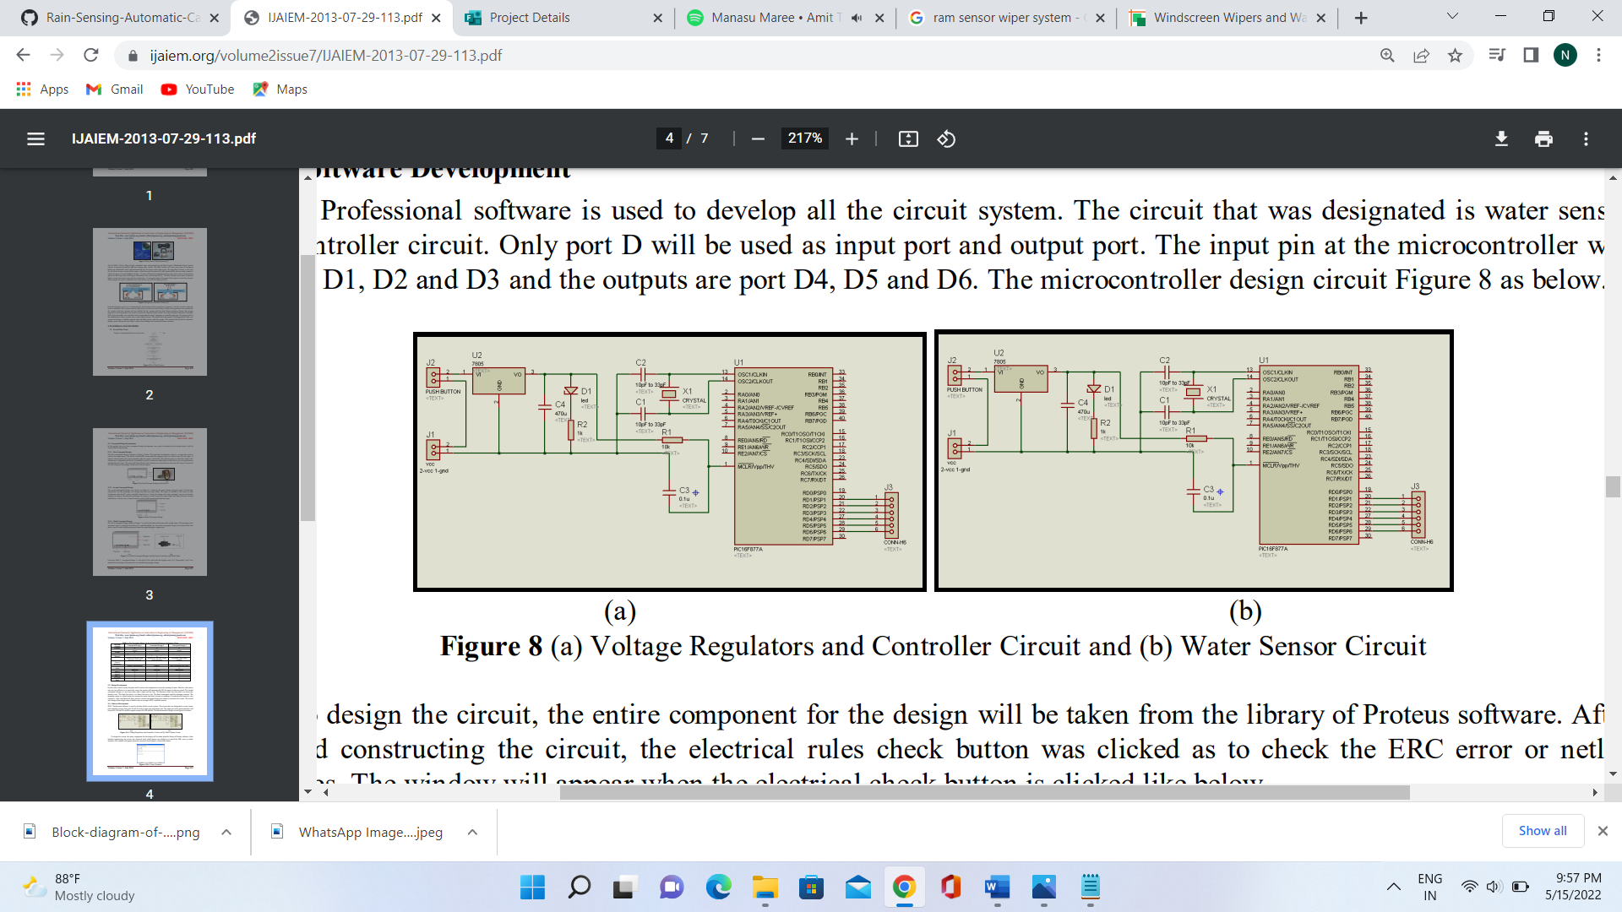

1. Voltage Regulators and Controller Circuit and (b) Water Sensor Circuit

To design the circuit, the entire component for the design will be taken from the library of Proteus software. After finished constructing the circuit, the electrical rules check button was clicked as to check the ERC error or netlist mistakes. The window will appear when the electrical check button is clicked like below.

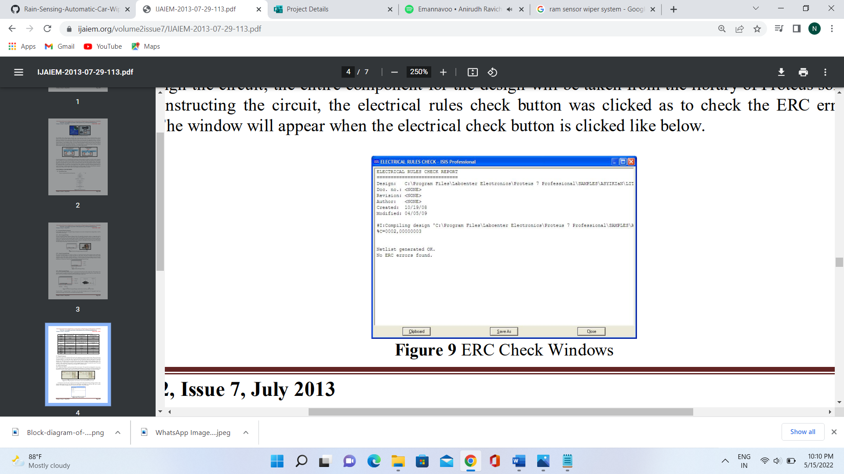

ERC Check Windows

After that, the ARES button was clicked to transfer the netlist into the ARES 7 Professional. The entire component from the circuit will be inserted manually one by one into the PCB design and arrange it manually. The final process is to connecting the component from one node to another node. The controller system designs show below was already to print to develop into PCB board.

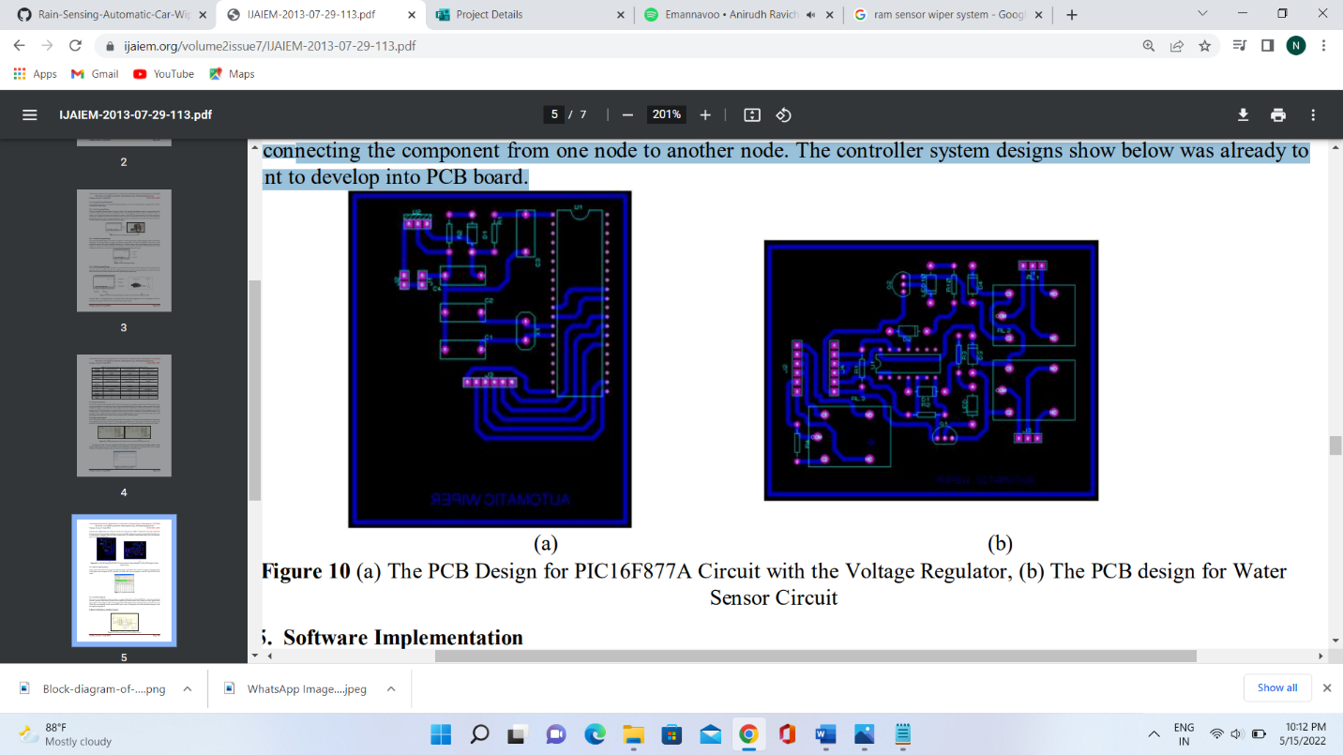  
(a) The PCB Design for PIC16F877A Circuit with the Voltage Regulator, (b) The PCB design for Water **Sensor Circuit**

Software Implementation In this project, the software that been used is PICC Compiler and PicKit2. This software is used for writing the coding of the project and to program the PIC controller [4]. Lastly, after write the program on the PIC chip, the PIC has to verify.

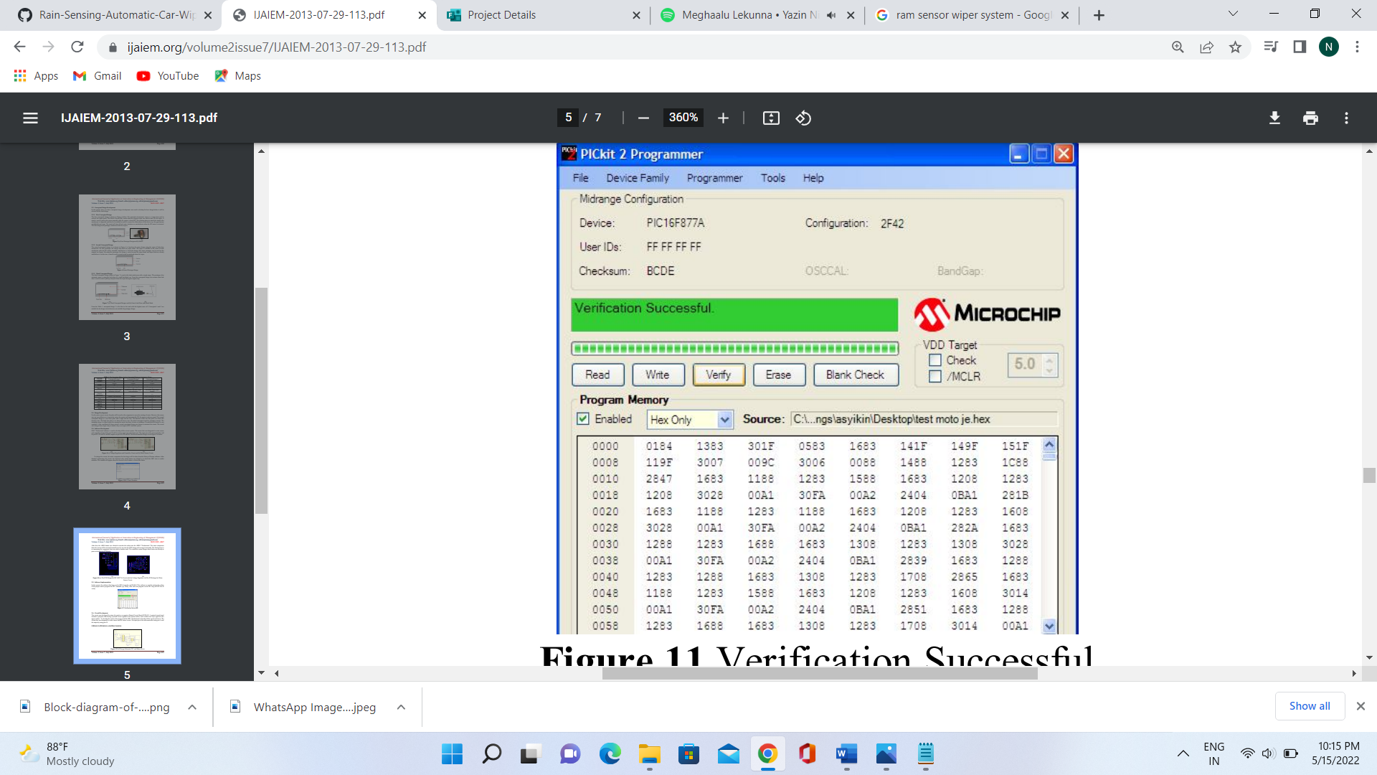

Verification Successful

**Circuit Development**

The circuit was developed by using the positive or negative Printed Circuit Board (PCB). A printed circuit board includes a polyester film having a printed circuit applied to the bottom surface and a metal cover layer applied to the upper surface. To develop the system, this project used the ISIS 7 Professional to develop all the circuit and run it. The circuit that was designated is water sensor and DC motor circuit. The input pin at the microcontroller using port A and the output by using port D.

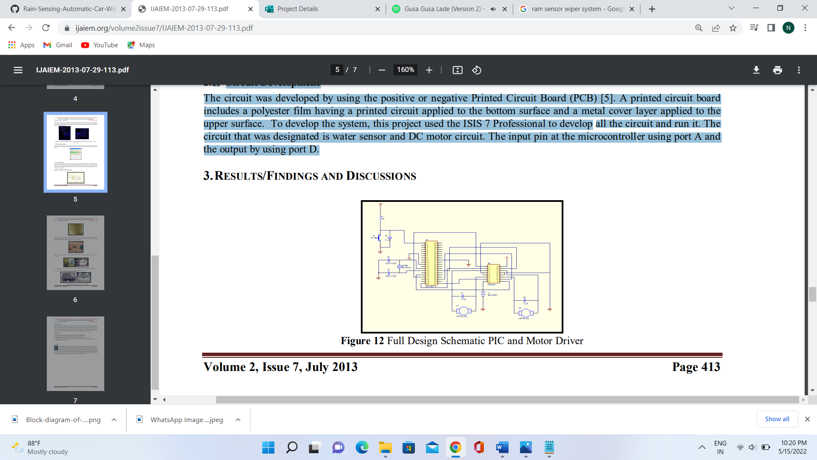

Full Design Schematic PIC and Motor Driver

Finally, all the circuits are connected to the real situation which at the back windscreen.

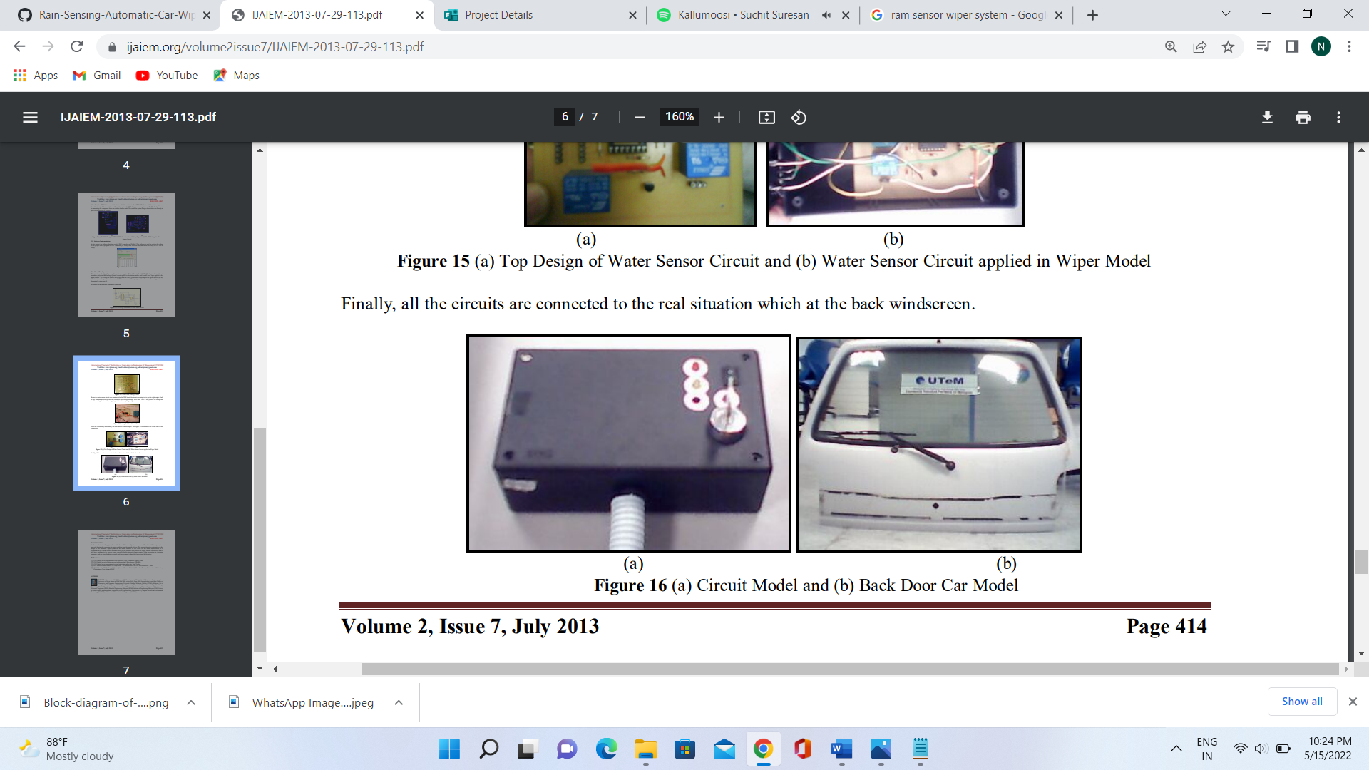

**CONCLUSION**

As the conclusion for the project, the results shows all the aim objectives are successfully achieved. The wiper system was well functionally according the water condition from the outside of a car. This project showed a contribution on the design of the automatic wiper system for the future research in this field. For the future improvement, it is recommended the system to have literature review on the material been used as the wiper, because the material used is still has a problem in the procure issues especially for the hot and climate country. Other suggestion for designing automatic push up wiper for future research and improvement is about the design stand for the wiper.

**References**

[1] (2013) http://www.howstuffworks.com/wiper.htm, How Windshield Wipers Work.

[2] (2013) http://www.the3rdeye.com.my/rainsensor.html, Rain Sensor (TE60RS). [3] (2013) http://www.sigmaautomotive.com/oedes/raintracker.php, Rain Tracker [4] D.W Smitch Oxford Newnes. PIC in practice: “An Introduction to the PIC Microcontroller”, 2002.

[5] Abdel Azzeh, “CAN Control System for an Electric Vehicle”, Bachelor Thesis, University of Canterbury Christchurch, New Zealand, 2005.